Testing Strategy for channel
The first thing to test in the channel is the Gilbert Fading module. It is programmed to generate an enabled signal with high for good channels and low for bad channels. Through the waveform, we should be able to observe the enabled signal changing which is shown on the figure.
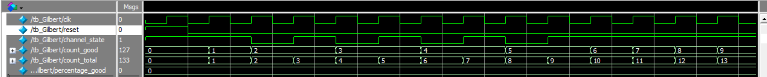
The following is to count the number of good states compared to the total. The steady-state ratio was calculated in Demo 1 which is 80%. As the figure is shown below, the Gilbert model is working as expected.
For the AWGN channel, there is no directing method to test AWGN, due to the look up table is stored in memory. Therefore, a few number of output is picked from look up table inside the mif file, and we implemented in our system. It did influence the signal.

